The Giant Jam Sandwich
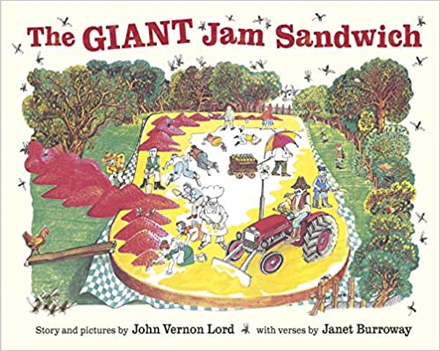

We listened / read the story and answered questions and pointed out key objects and characters from the story.

Comments:

