A few ideas to support the development of gross motor skills (large body movements and control)
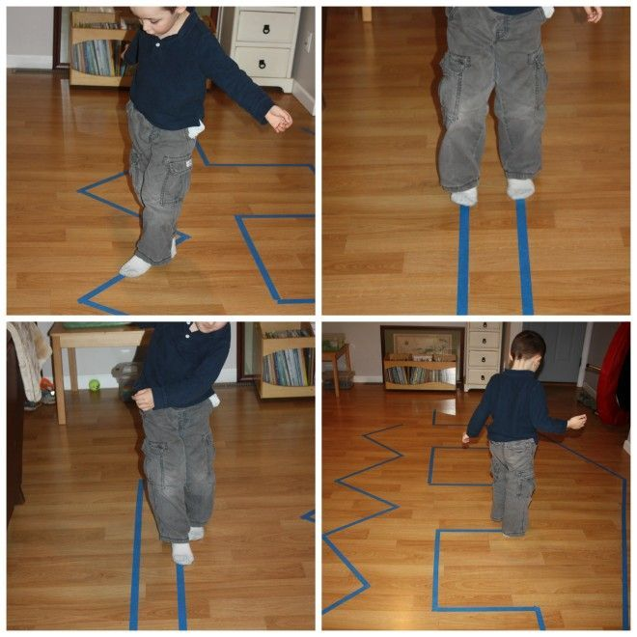

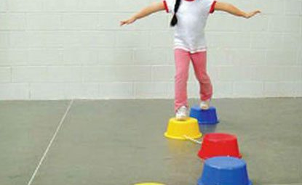
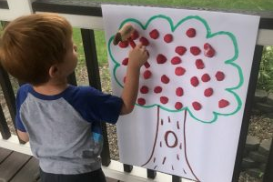
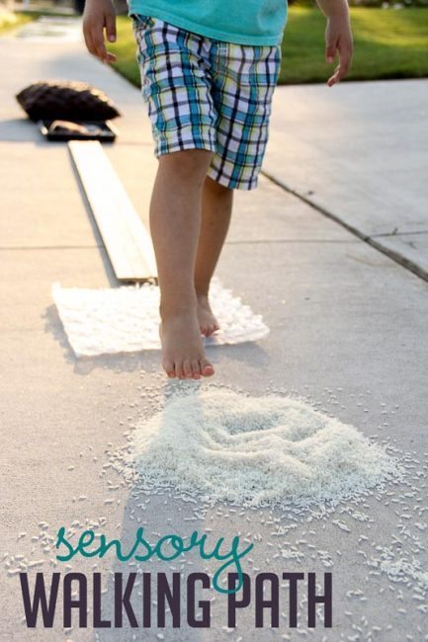
- The Floor is Lava: Use targets on the floor for your child to stretch their legs to reach and then balance on the small space.
- A Flash Light Scavenger Hunt: Turn off the lights and hide some objects around the house for your child to find with a torch.
- Target Practice: Set up a target practice for your child to throw something at it (like a beanbag or a ball) or use a water pistol.
- String Scavenger Hunt: String some string around the room, through chairs and set up treasures along the way to find! Have them follow it through, going in and out, under and over to see what they can find!
- A Spy Game: Tape up a ‘spider web’ for them to crawl through. Stick pom poms or cotton balls for them to pick up.
- Jumping Game: See how far they can jump.
- Newspaper: Create an indoor basketball with newspaper.
- Bean Bag Toss: Label your stairs with numbers and throw bean bags to land on each stair. Make it harder to land on them in order.

