Call and response – Kestrel Classes favourite dance and action songs
Go Noodle - Milkshake
https://www.youtube.com/watch?v=dNL6RwymoNg
Go Noodle - Dino Stomp
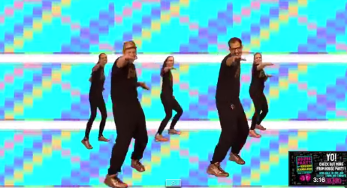
https://www.youtube.com/watch?v=Imhi98dHa5w
Go Noodle - Banana, banana, meetball
https://www.youtube.com/watch?v=BQ9q4U2P3ig
Go Noodle – Get yo body moving
https://www.youtube.com/watch?v=fpD9kRyBn8o
The days of the week song
https://www.youtube.com/watch?v=mXMofxtDPUQ
The months of the year
https://www.youtube.com/watch?v=Fe9bnYRzFvk
Wash your hands song
https://www.youtube.com/watch?v=dDHJW4r3elE
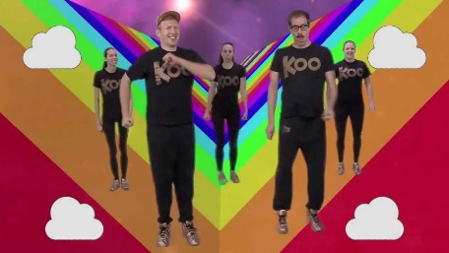
Shapes song
https://www.youtube.com/watch?v=OEbRDtCAFdU
Boom Chika Boom
https://www.youtube.com/watch?v=F2XVfTzel8E
The clean up song
https://www.youtube.com/watch?v=gPq7wzGEjqE

