[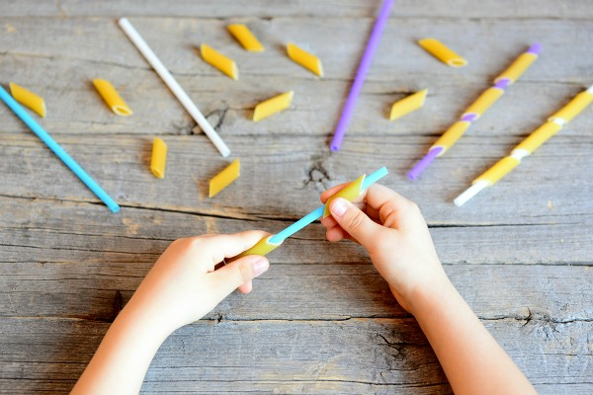](https://www.google.co.uk/url?sa=i&url=https%3A%2F%2Fwww.merakilane.com%2Factivities-develop-fine-motor-skills-18-ways-fun-home%2F&psig=AOvVaw2XZpPXcS2UJA7WZlCQGTds&ust=1589422701007000&source=images&cd=vfe&ved=0CAIQjRxqFwoTCKDW3Jjjr-kCFQAAAAAdAAAAABAD)[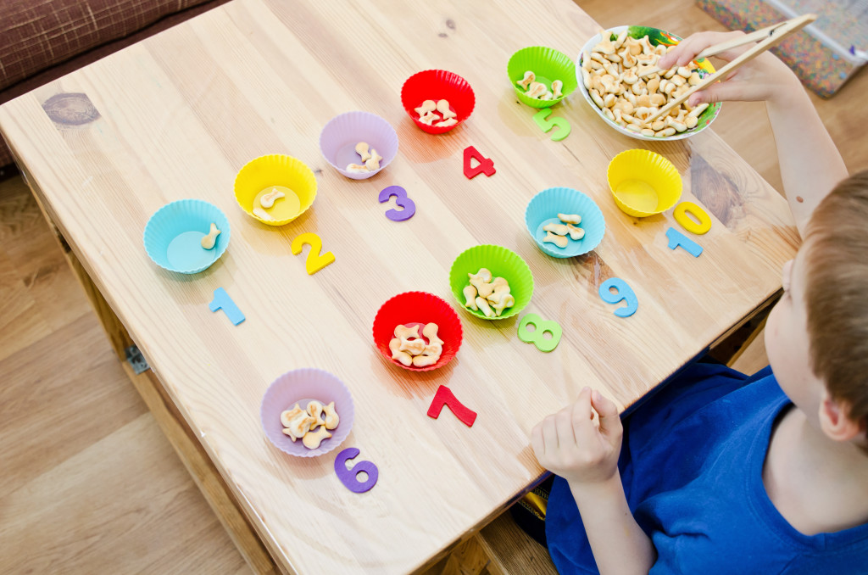](https://www.google.co.uk/url?sa=i&url=https%3A%2F%2Fwww.childrenstherapyteam.com%2Findex.php%2F2017%2F01%2F09%2Ffine-motor-skills%2F&psig=AOvVaw172JG4mRBJJyyz7I2TAnNH&ust=1589422843130000&source=images&cd=vfe&ved=0CAIQjRxqFwoTCPCgod3jr-kCFQAAAAAdAAAAABAD)[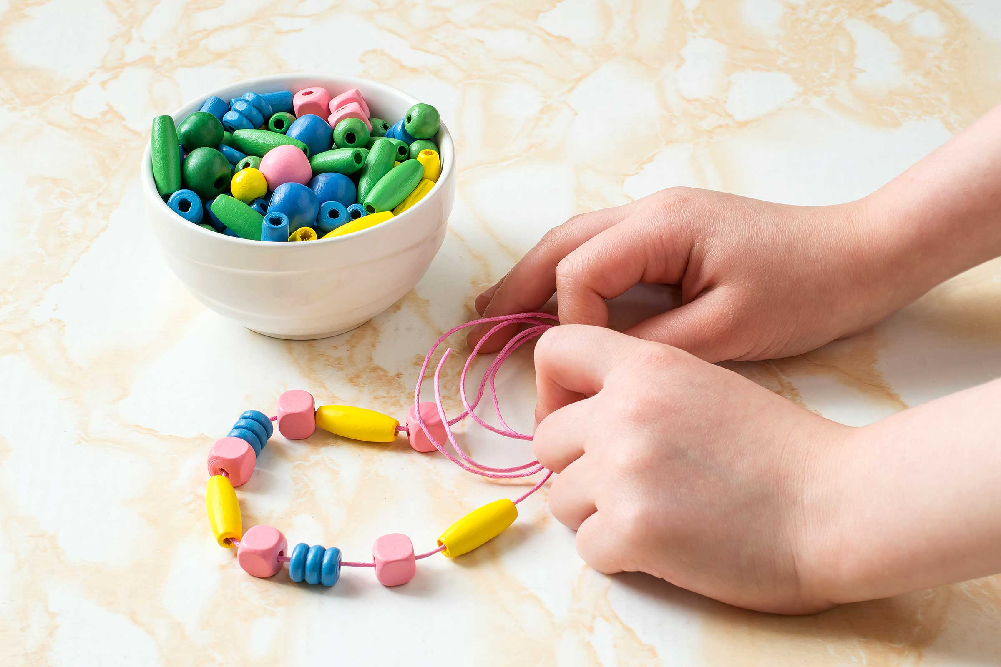](https://www.google.co.uk/url?sa=i&url=https%3A%2F%2Fwww.rd.com%2Fadvice%2Fparenting%2Ffine-motor-skills%2F&psig=AOvVaw172JG4mRBJJyyz7I2TAnNH&ust=1589422843130000&source=images&cd=vfe&ved=0CAIQjRxqFwoTCPCgod3jr-kCFQAAAAAdAAAAABAK)[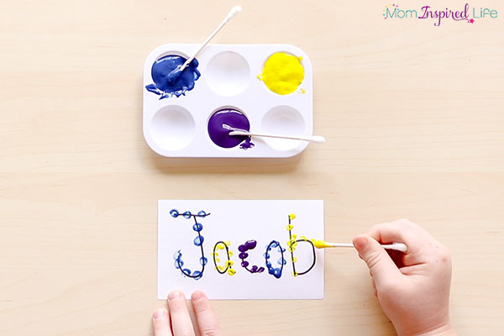](https://www.google.co.uk/url?sa=i&url=https%3A%2F%2Ffunlearningforkids.com%2Ffavorite-fine-motor-activities-preschoolers%2F&psig=AOvVaw172JG4mRBJJyyz7I2TAnNH&ust=1589422843130000&source=images&cd=vfe&ved=0CAIQjRxqFwoTCPCgod3jr-kCFQAAAAAdAAAAABAR)[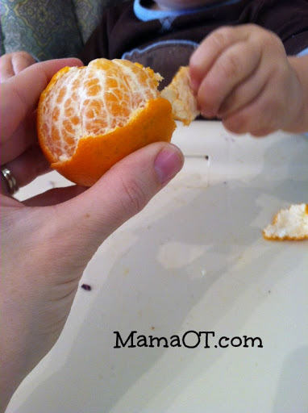](https://www.google.co.uk/url?sa=i&url=http%3A%2F%2Fmamaot.com%2Ffine-motor-activities-using-household-items%2F&psig=AOvVaw172JG4mRBJJyyz7I2TAnNH&ust=1589422843130000&source=images&cd=vfe&ved=0CAIQjRxqFwoTCPCgod3jr-kCFQAAAAAdAAAAABAZ)[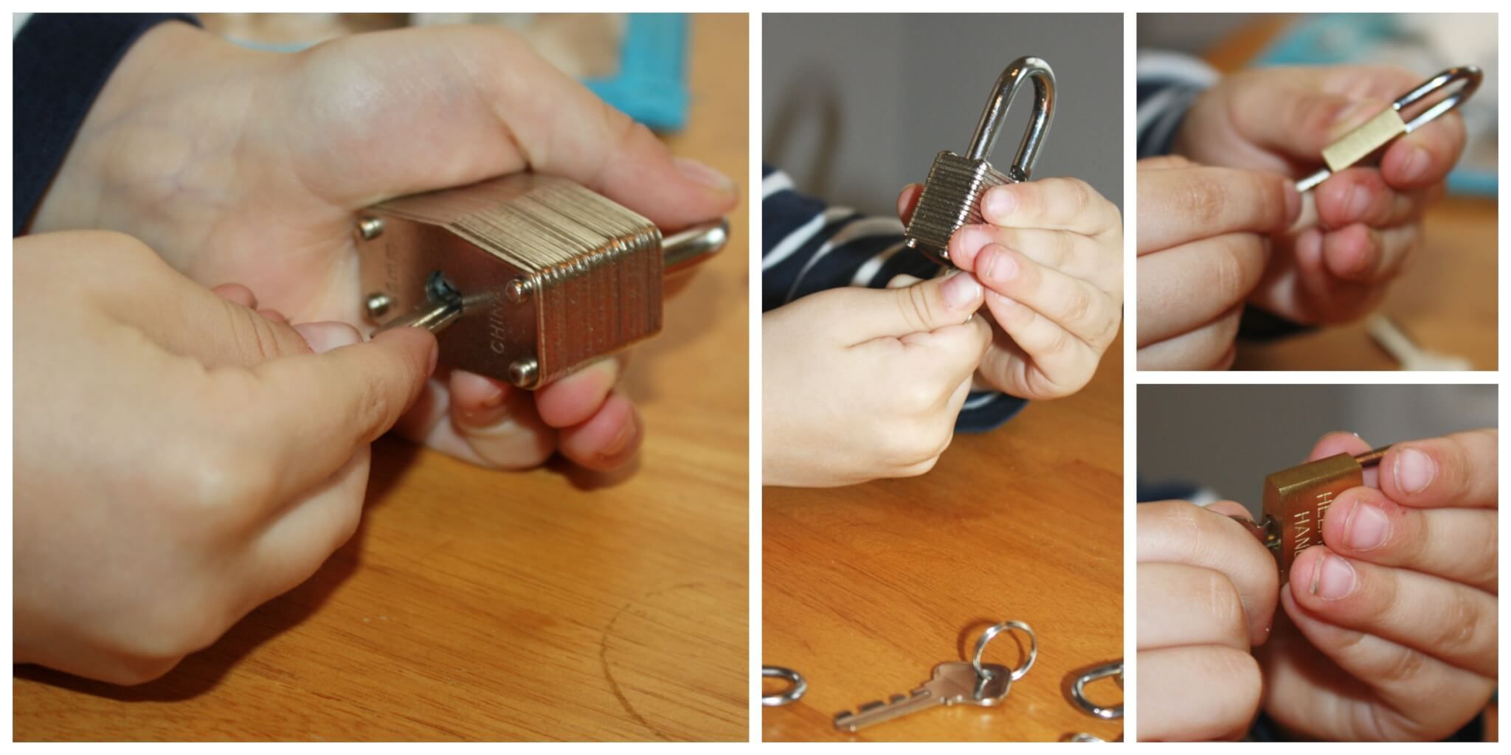](https://www.google.co.uk/url?sa=i&url=https%3A%2F%2Flittlebinsforlittlehands.com%2Fpractical-life-fine-motor-skills-learning-activities%2F&psig=AOvVaw2ZWKOHXFEvm3Nx3vRCU5nB&ust=1589423220199000&source=images&cd=vfe&ved=0CAIQjRxqFwoTCNi5kZXlr-kCFQAAAAAdAAAAABAD)[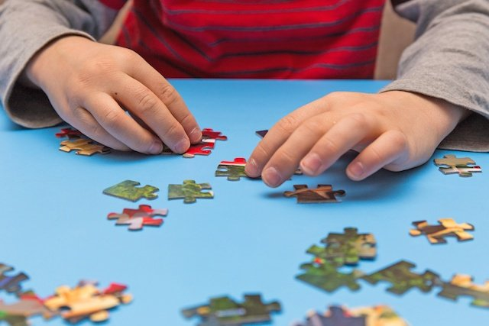](https://www.google.co.uk/url?sa=i&url=https%3A%2F%2Fblog.brainbalancecenters.com%2F2015%2F05%2Fsigns-of-fine-motor-delay-and-how-to-improve-fine-motor-skills&psig=AOvVaw2ZWKOHXFEvm3Nx3vRCU5nB&ust=1589423220199000&source=images&cd=vfe&ved=0CAIQjRxqFwoTCNi5kZXlr-kCFQAAAAAdAAAAABAJ)[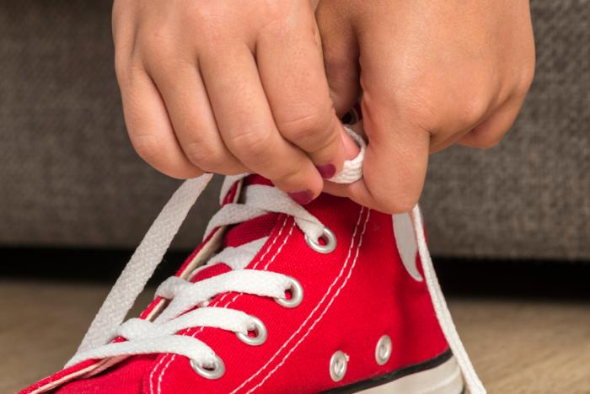](https://www.google.co.uk/url?sa=i&url=https%3A%2F%2Fwww.medicalnewstoday.com%2Farticles%2F151951&psig=AOvVaw2ZWKOHXFEvm3Nx3vRCU5nB&ust=1589423220199000&source=images&cd=vfe&ved=0CAIQjRxqFwoTCNi5kZXlr-kCFQAAAAAdAAAAABAR)[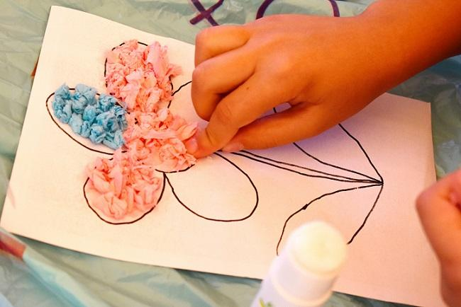](https://www.google.co.uk/url?sa=i&url=https%3A%2F%2Fsensoryprocessingdisorderparentsupport.com%2Ffine-motor-skills-and-activities.php&psig=AOvVaw2AVpysyohE0E23CWHHo03L&ust=1589423334444000&source=images&cd=vfe&ved=0CAIQjRxqFwoTCOiXwcnlr-kCFQAAAAAdAAAAABAR)[](https://www.google.co.uk/url?sa=i&url=https%3A%2F%2Fwww.flintrehab.com%2F2020%2Ffine-motor-skills-after-stroke%2F&psig=AOvVaw2AVpysyohE0E23CWHHo03L&ust=1589423334444000&source=images&cd=vfe&ved=0CAIQjRxqFwoTCOiXwcnlr-kCFQAAAAAdAAAAABAg) [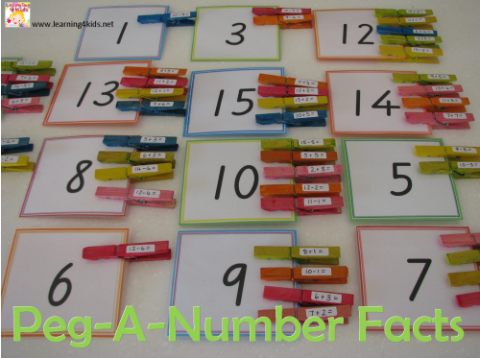](https://www.google.co.uk/url?sa=i&url=https%3A%2F%2Fwww.learning4kids.net%2F2015%2F01%2F18%2Factivity-ideas-using-pegs%2F&psig=AOvVaw0wcwB2GwyS6Ws3G_VgJaBt&ust=1589423549182000&source=images&cd=vfe&ved=0CAIQjRxqFwoTCLCgq939sOkCFQAAAAAdAAAAABAD) [](https://www.google.co.uk/url?sa=i&url=https%3A%2F%2Fraisingchildren.net.au%2Fguides%2Factivity-guides%2Fpeg-play-activity-for-children-2-4-years&psig=AOvVaw0wcwB2GwyS6Ws3G_VgJaBt&ust=1589423549182000&source=images&cd=vfe&ved=0CAIQjRxqFwoTCLCgq939sOkCFQAAAAAdAAAAABAK) [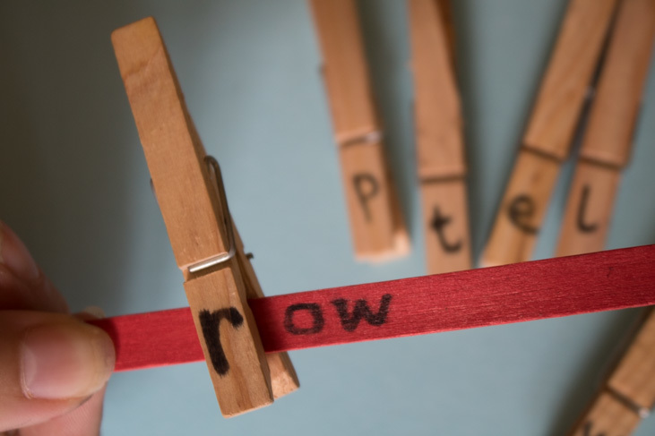](https://www.google.co.uk/url?sa=i&url=https%3A%2F%2Fparentshomeworkhub.com%2Fpeg-and-popsicle-stick-words%2F&psig=AOvVaw0wcwB2GwyS6Ws3G_VgJaBt&ust=1589423549182000&source=images&cd=vfe&ved=0CAIQjRxqFwoTCLCgq939sOkCFQAAAAAdAAAAABAR) [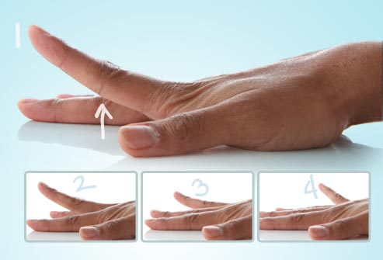](https://www.google.co.uk/url?sa=i&url=https%3A%2F%2Fwww.webmd.com%2Fosteoarthritis%2Fss%2Fslideshow-hand-finger-exercises&psig=AOvVaw1W52SYhqiAo5fV8RjM3bHA&ust=1589465464707000&source=images&cd=vfe&ved=0CAIQjRxqFwoTCPD3o8CCsekCFQAAAAAdAAAAABAe)