[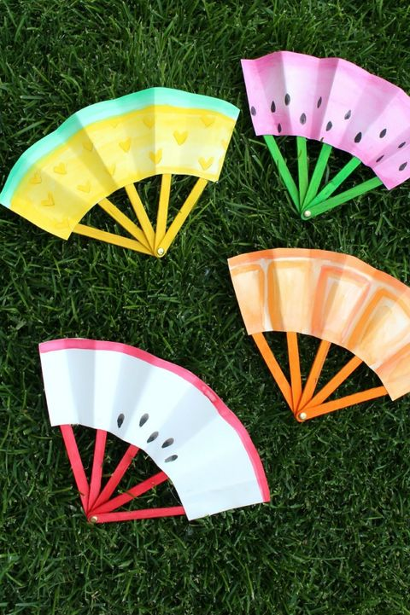](https://www.google.co.uk/url?sa=i&url=https%3A%2F%2Fwww.goodhousekeeping.com%2Fhome%2Fcraft-ideas%2Fg20967550%2Fsummer-crafts%2F&psig=AOvVaw2Ezjg-2gGaAXVt1Ht-bW_X&ust=1594295493867000&source=images&cd=vfe&ved=0CAIQjRxqFwoTCLj6ibzMveoCFQAAAAAdAAAAABAD) [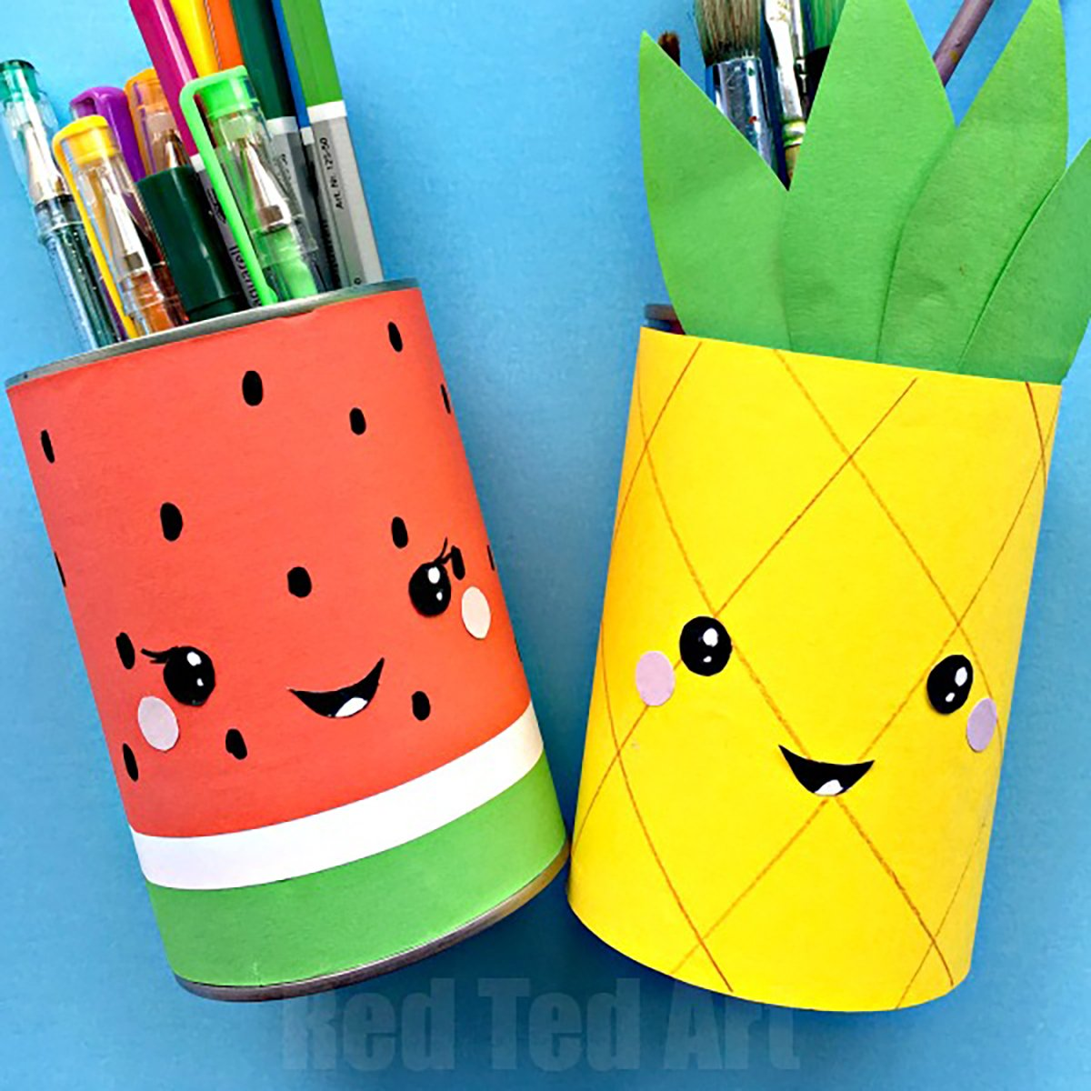](https://www.google.co.uk/url?sa=i&url=https%3A%2F%2Fwww.tasteofhome.com%2Fcollection%2Ffun-summer-crafts%2F&psig=AOvVaw2Ezjg-2gGaAXVt1Ht-bW_X&ust=1594295493867000&source=images&cd=vfe&ved=0CAIQjRxqFwoTCLj6ibzMveoCFQAAAAAdAAAAABAK)

[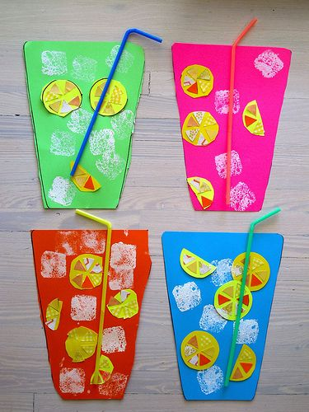](https://www.google.co.uk/url?sa=i&url=https%3A%2F%2Fwww.pinterest.com%2Fpin%2F486388828487244670%2F&psig=AOvVaw2Ezjg-2gGaAXVt1Ht-bW_X&ust=1594295493867000&source=images&cd=vfe&ved=0CAIQjRxqFwoTCLj6ibzMveoCFQAAAAAdAAAAABAQ) [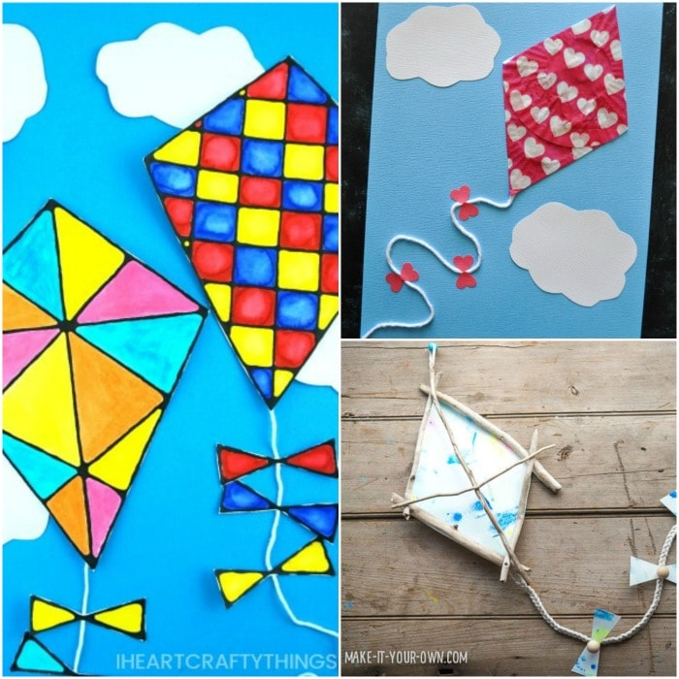](https://www.google.co.uk/url?sa=i&url=https%3A%2F%2Fiheartcraftythings.com%2Fsummer-crafts-for-kids.html&psig=AOvVaw2Ezjg-2gGaAXVt1Ht-bW_X&ust=1594295493867000&source=images&cd=vfe&ved=0CAIQjRxqFwoTCLj6ibzMveoCFQAAAAAdAAAAABAW)

[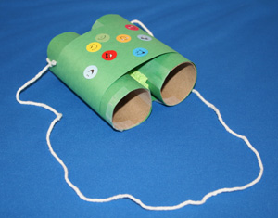](https://www.google.co.uk/url?sa=i&url=https%3A%2F%2Fwww.allkidsnetwork.com%2Fcrafts%2Fdress-up%2Fbinoculars-craft&psig=AOvVaw2KMGP3uHTnZsvoA5wcWMo6&ust=1594295947744000&source=images&cd=vfe&ved=0CAIQjRxqFwoTCMjaudHNveoCFQAAAAAdAAAAABAD)[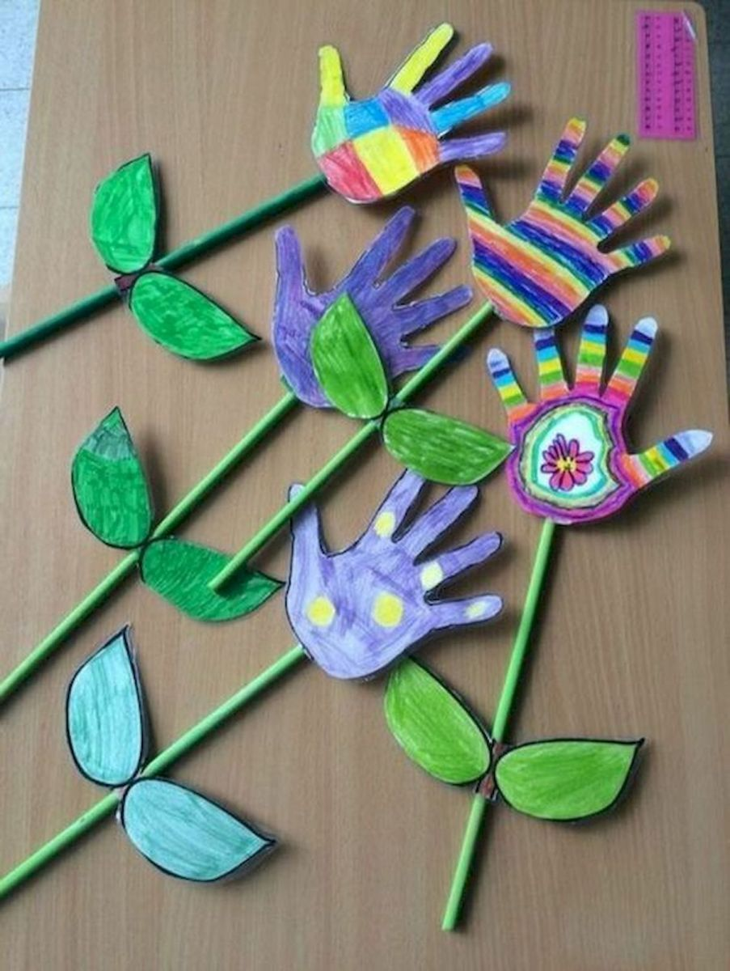](https://www.google.co.uk/url?sa=i&url=https%3A%2F%2Fgoogodecor.com%2Feasy-summer-crafts-ideas-for-kids%2Feasy-summer-crafts-ideas-for-kids-19%2F&psig=AOvVaw3O3X6MLSsosRK_sjF1DM-E&ust=1594296000711000&source=images&cd=vfe&ved=0CAIQjRxqFwoTCMj8m_PNveoCFQAAAAAdAAAAABAE)[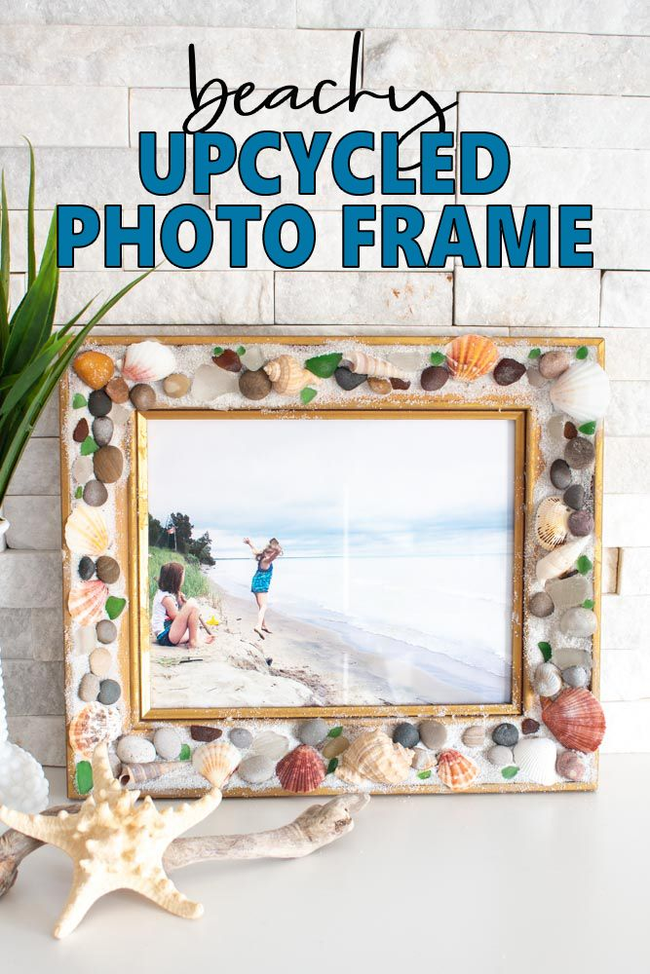](https://www.google.co.uk/url?sa=i&url=https%3A%2F%2Fwww.pinterest.com%2Fpin%2F799881583798981122%2F&psig=AOvVaw3x_FRuiMONlrprEbiHiQAY&ust=1594296151901000&source=images&cd=vfe&ved=0CAIQjRxqFwoTCIi42rLOveoCFQAAAAAdAAAAABAD)