[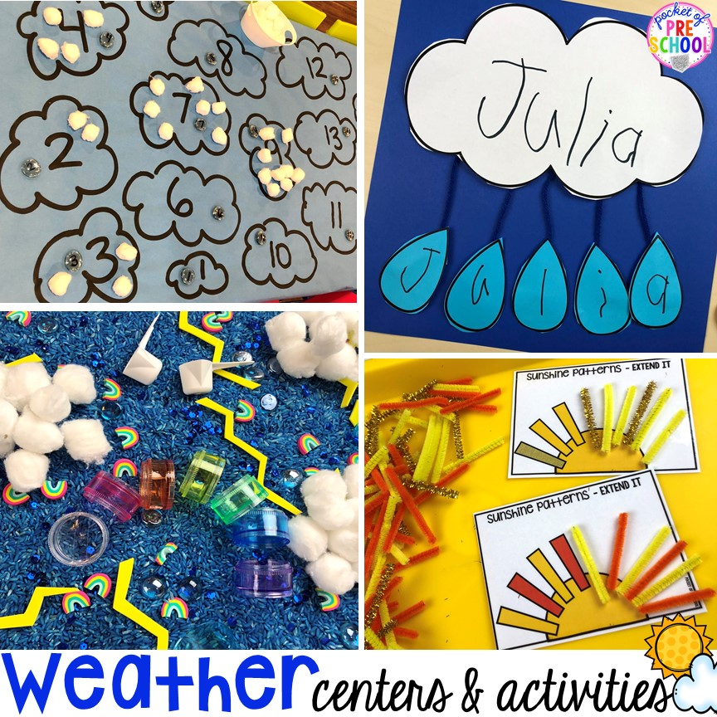](https://www.google.co.uk/url?sa=i&url=https%3A%2F%2Fpocketofpreschool.com%2Fweather-activities-and-centers%2F&psig=AOvVaw2ISnNcDKnAdPYtQidSH5Zc&ust=1590793989820000&source=images&cd=vfe&ved=0CAIQjRxqFwoTCKjMitDX1-kCFQAAAAAdAAAAABAD)

[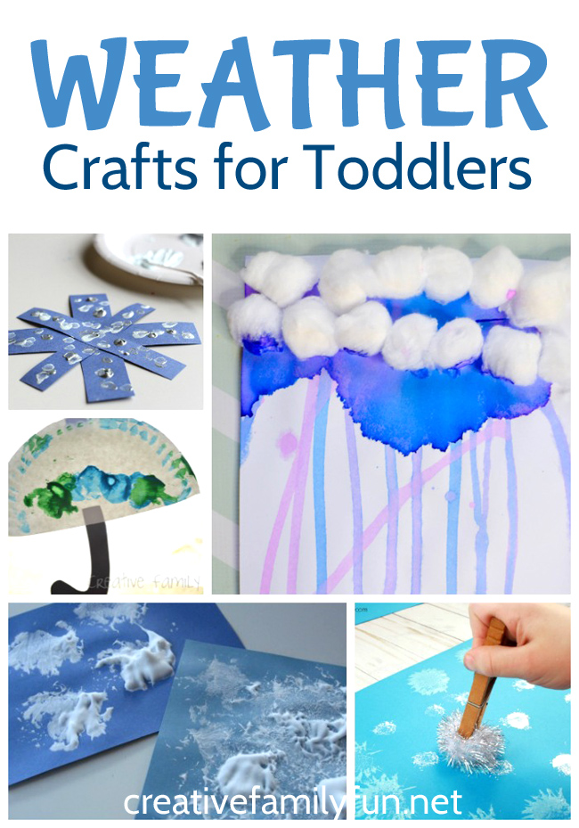](https://www.google.co.uk/url?sa=i&url=https%3A%2F%2Fcreativefamilyfun.net%2Fweather-crafts-for-toddlers%2F&psig=AOvVaw2FkV4IMNvbeBFDrKok3iMz&ust=1590794158462000&source=images&cd=vfe&ved=0CAIQjRxqFwoTCMDnsqDY1-kCFQAAAAAdAAAAABAD)

[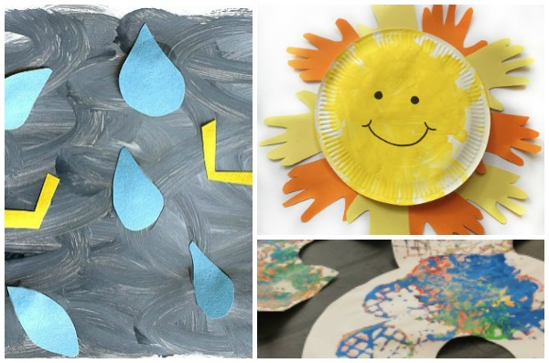](https://www.google.co.uk/url?sa=i&url=https%3A%2F%2Fwww.craftsonsea.co.uk%2Fweather-crafts-for-toddlers%2F&psig=AOvVaw2FkV4IMNvbeBFDrKok3iMz&ust=1590794158462000&source=images&cd=vfe&ved=0CAIQjRxqFwoTCMDnsqDY1-kCFQAAAAAdAAAAABAK)