[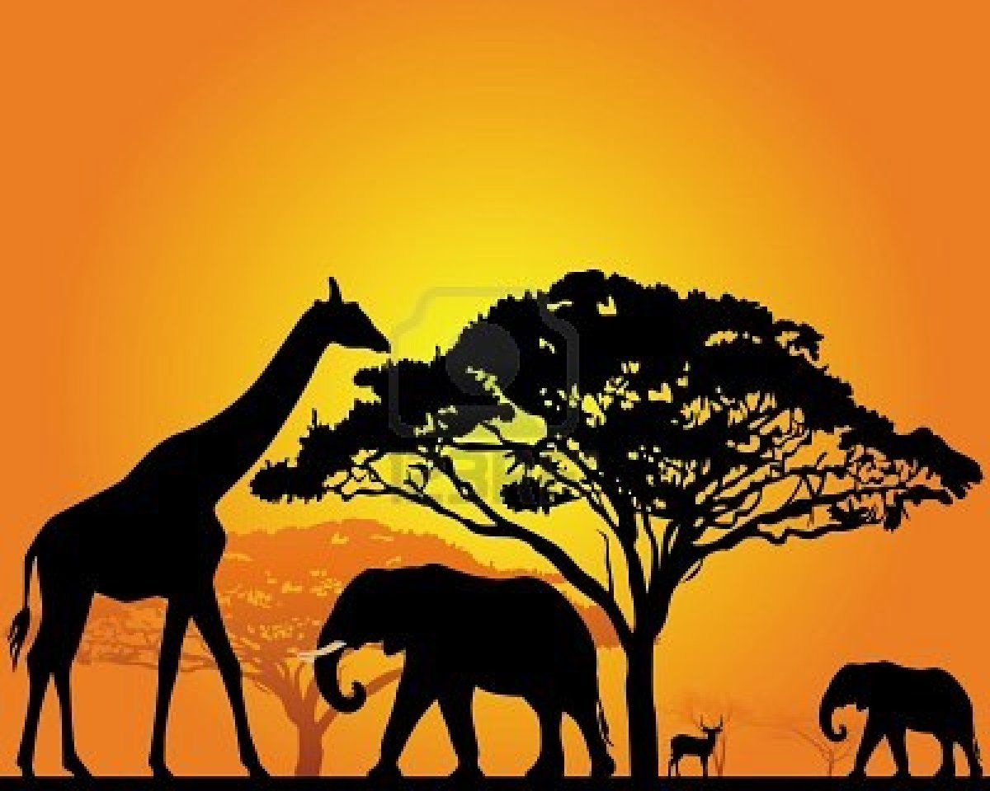](https://www.google.co.uk/url?sa=i&url=https%3A%2F%2Fwww.pinterest.com.au%2Fpin%2F356206651747343193%2F&psig=AOvVaw2BJ_uos8PROJa_2ySDe1g1&ust=1589421460575000&source=images&cd=vfe&ved=0CAIQjRxqFwoTCPC53sfer-kCFQAAAAAdAAAAABAD)[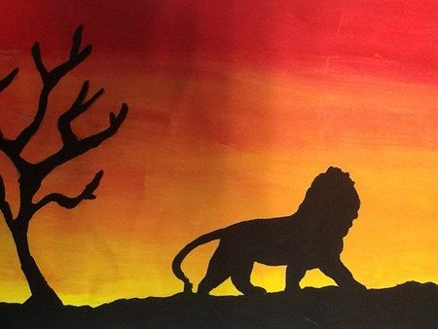](https://www.google.co.uk/url?sa=i&url=https%3A%2F%2Fwww.clipart.email%2Fclipart%2Fafrican-silhouette-art-lesson-102304.html&psig=AOvVaw2BJ_uos8PROJa_2ySDe1g1&ust=1589421460575000&source=images&cd=vfe&ved=0CAIQjRxqFwoTCPC53sfer-kCFQAAAAAdAAAAABAI)[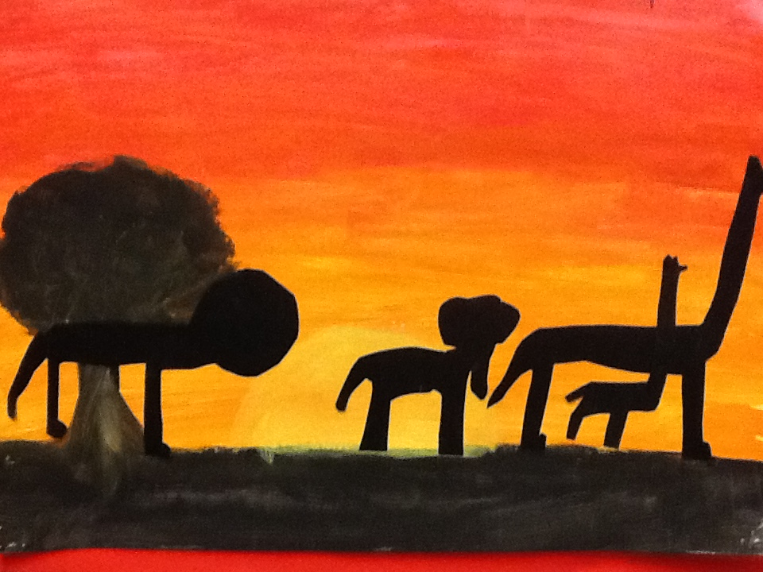](https://www.google.co.uk/url?sa=i&url=https%3A%2F%2Fwww.clipart.email%2Fclipart%2Fafrican-silhouette-art-ks1-102451.html&psig=AOvVaw2BJ_uos8PROJa_2ySDe1g1&ust=1589421460575000&source=images&cd=vfe&ved=0CAIQjRxqFwoTCPC53sfer-kCFQAAAAAdAAAAABAT)[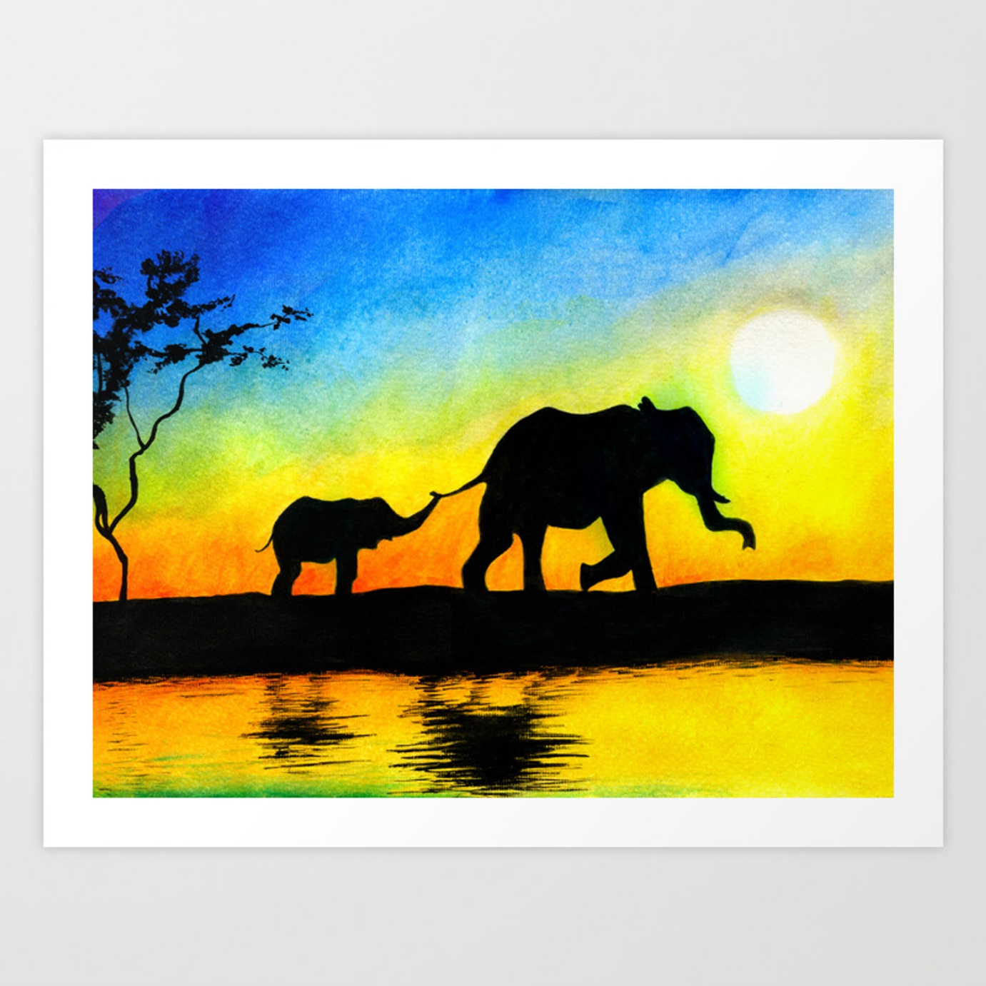](https://www.google.co.uk/url?sa=i&url=https%3A%2F%2Fsociety6.com%2Fproduct%2Fwatercolor-sunset-elephants-silhouette-africa-painting_print&psig=AOvVaw2BJ_uos8PROJa_2ySDe1g1&ust=1589421460575000&source=images&cd=vfe&ved=0CAIQjRxqFwoTCPC53sfer-kCFQAAAAAdAAAAABAZ)[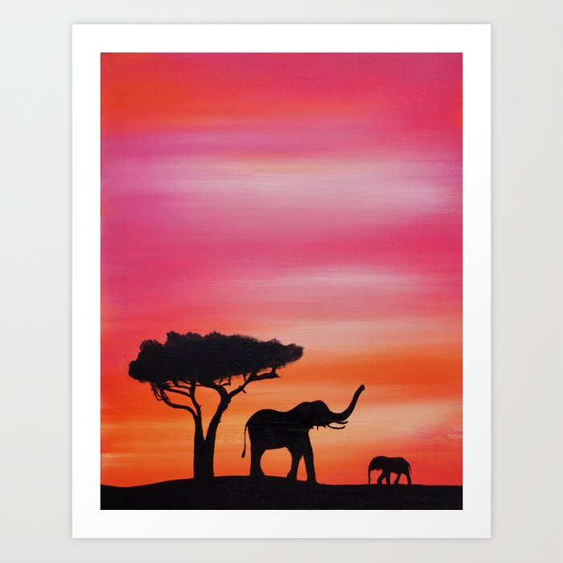](https://www.google.co.uk/url?sa=i&url=https%3A%2F%2Fsociety6.com%2Fproduct%2Fafrican-sunset-safari-elephant-silhouette-painting_print&psig=AOvVaw2BJ_uos8PROJa_2ySDe1g1&ust=1589421460575000&source=images&cd=vfe&ved=0CAIQjRxqFwoTCPC53sfer-kCFQAAAAAdAAAAABAg)[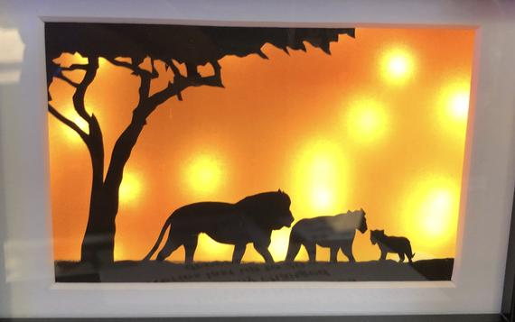](https://www.google.co.uk/url?sa=i&url=https%3A%2F%2Fwww.etsy.com%2Fsg-en%2Flisting%2F685919230%2Fthe-african-lions-silhouette-light-frame&psig=AOvVaw2BJ_uos8PROJa_2ySDe1g1&ust=1589421460575000&source=images&cd=vfe&ved=0CAIQjRxqFwoTCPC53sfer-kCFQAAAAAdAAAAABAn)[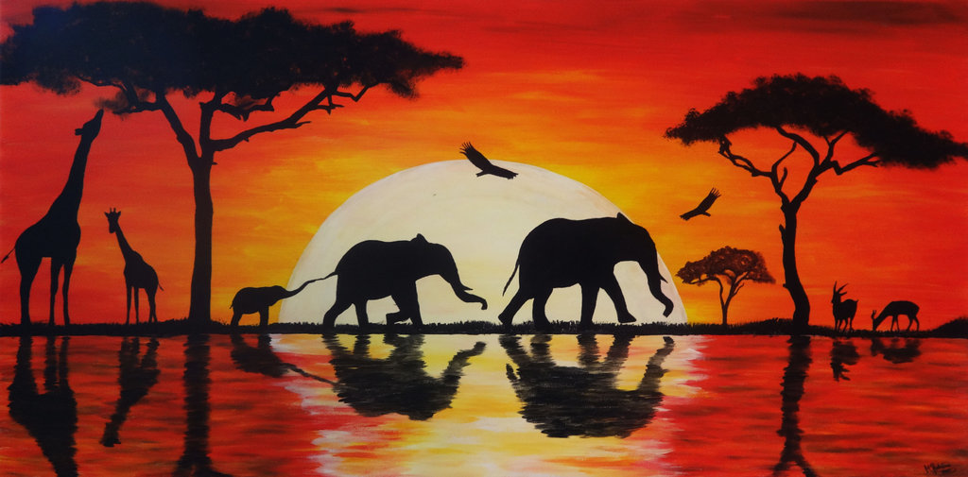](https://www.google.co.uk/url?sa=i&url=https%3A%2F%2Fpaintingvalley.com%2Fafrican-sunset-painting&psig=AOvVaw2BJ_uos8PROJa_2ySDe1g1&ust=1589421460575000&source=images&cd=vfe&ved=0CAIQjRxqFwoTCPC53sfer-kCFQAAAAAdAAAAABAu)