Where the Wild Things are – Character Description
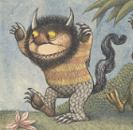
Hair colour | Hair length
Eye colour | Horns
Claws | Tail
Legs | Body
Teeth | Feet

