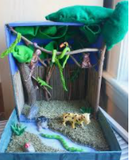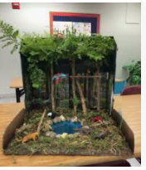

Weekly Project

Encourage your child to make his/her favourite habitat.

Watch short YouTube video clips about rainforest and desert habitats.
Encourage your child to recall some facts from the previous week about the red-eyed frogs and kangaroos.
Use an IPad to identify some features of the rainforest and desert habitats.
Use pictures from google images.
Where do red–eyed frogs/kangaroos live? What plants can you see? What other animals live in the rainforest/desert?
Encourage your child to use different coloured/textured fabrics, paper, materials etc… to make either a rainforest or desert habitat.



