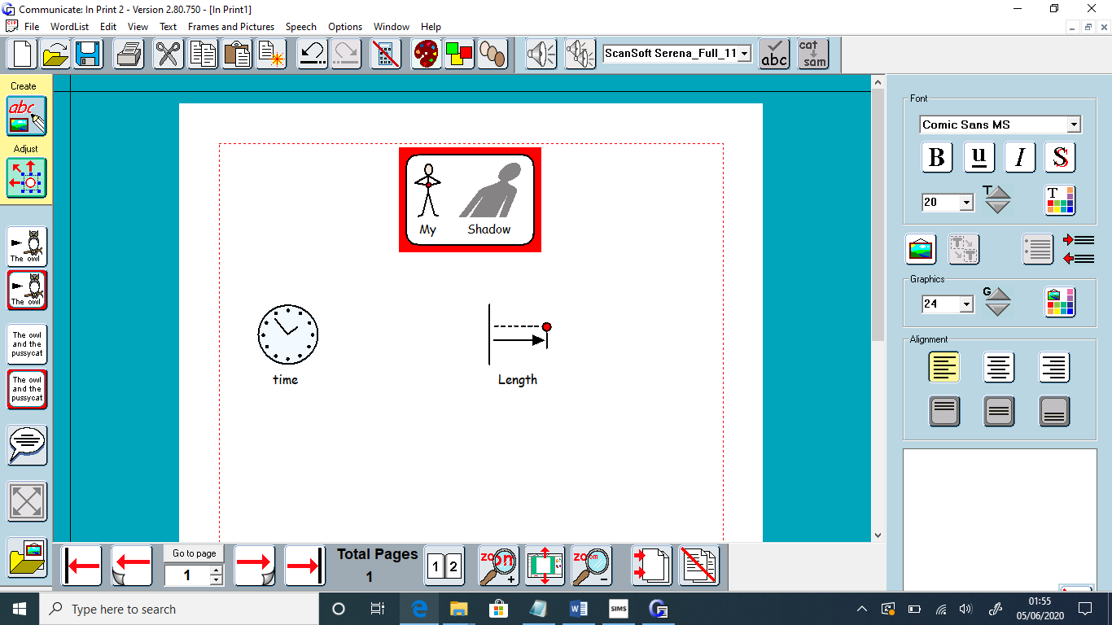
Can you measure the length of your shadow during the day?
How could you measure it?
Does it change?
What is the difference?
Why do you think it might change?


