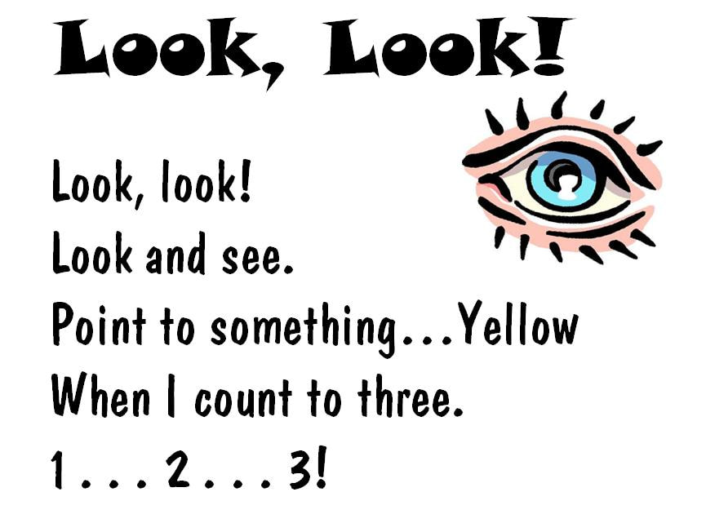
More fun with phonics
Rhythm and rhyme
To develop children’s experiences and understanding of rhythm and rhyme in speech, try reading rhyming stories, play rhyming bingo, clap out the syllables in words and play the odd one out game (Letters and Sounds phase one folder).
Alliteration

Look at the initial sounds of words, with activities including I-Spy type games and matching objects which begin with the same sound. Try this tongue twister “Six super sausages sizzling spectacularly”. Can you make up your own alliterative tongue twisters?
Voice sounds
Have a go at distinguishing between the different vocal sounds of letters, this is called oral blending and segmenting. Activities include Metal Mike, where children feed pictures of objects into a toy robot's mouth and the adult sounds out the name of the object in a robot voice /c/u/p/ cup, with the children joining in. If you don’t have a robot handy, make one out of an old cereal packet.
Oral blending and segmenting
You can develop oral blending and segmenting skills by saying some sounds, such as /c/u/p/ and see whether the children can pick out a cup from a group of objects. For segmenting practise, the teacher could hold up an object such as a sock and ask the children which sounds they can hear in the word sock.

