LO – to know the story of the Room on the Broom.
I can:
- Say what the picture is.
- Write the correct letter sound for the start of the word.
 _____at
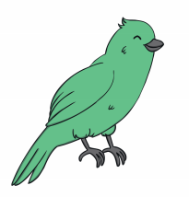 _____ ird
 _____ o g
 _____rog
_____ragon
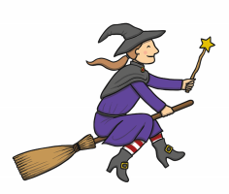 _____itch
 ______at

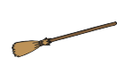______roomstick

_______ow

 _____lait
 ______and
 _____auldron

